DAY 25: osTicket + ELK Integration
Summary: Today, I will integrate <place holder>

- Create an API key from the osTicket page:
Switch to Admin Panel > Manage > API Keys > Add New API Key. Then, enter the ELK server’s private IP address into “IP Address” entry and tick “Can Create Tickets” checkbox:
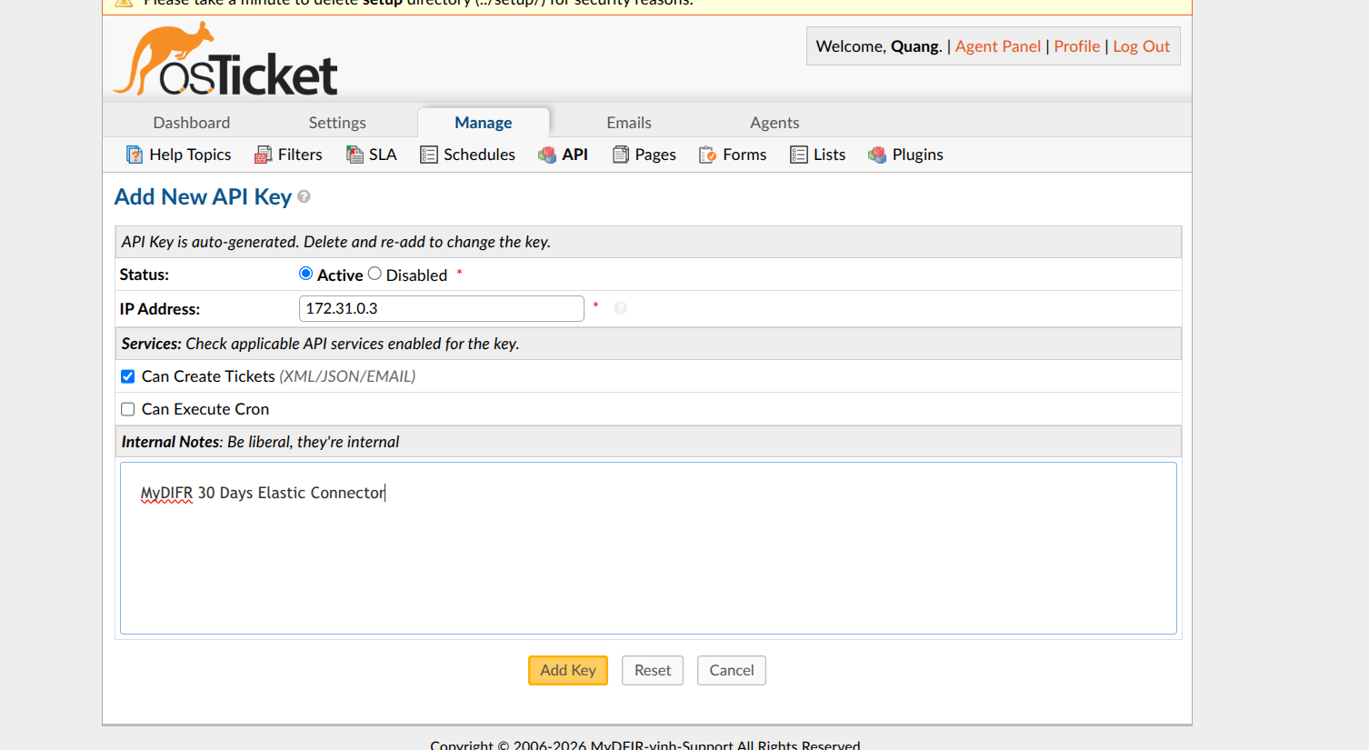
Figure 1: Create API key on osTicket
The API Key was generated: QF9BRSW89ZCZJTZ8YVHSKQCAIUSV2U0GDV9MUXF0JAGQVA9M
- Integrate into ELK
Because Free license is not allow to use call API features to another applications, so I must active it (with free trial 30 days license):
Go to the Stack management > License Management > Select “Start a 30-day trial” > Start my trial:

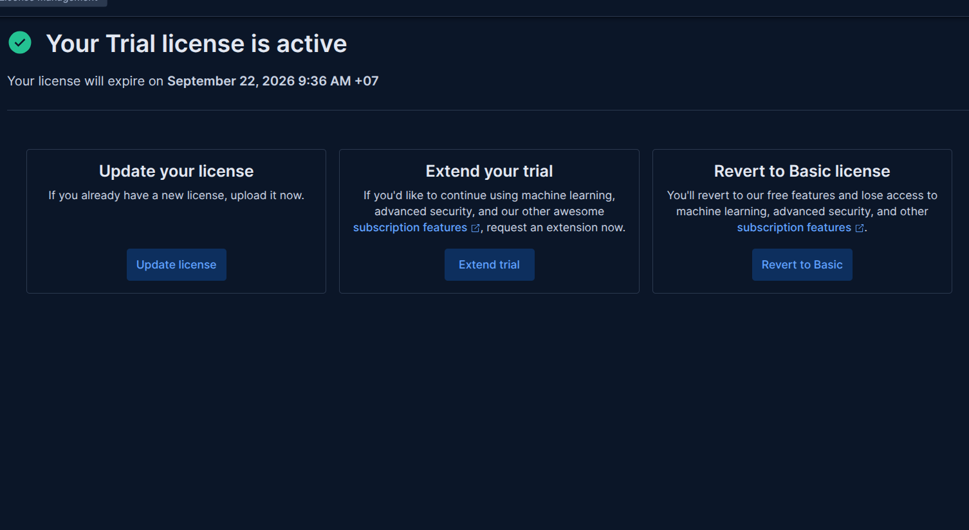
Figure 2: Successful free trial activation

Now, I will add a connector to connect the osTicket application into my ELK Stack. I’ll use the Webhook connector, which allows Elastic to send HTTP requests to the osTicket web service. To find it, type “webhook” keyword in the connectors list and select Webhook Connector. Be careful not to select the Webhook - Case Management by mistake !
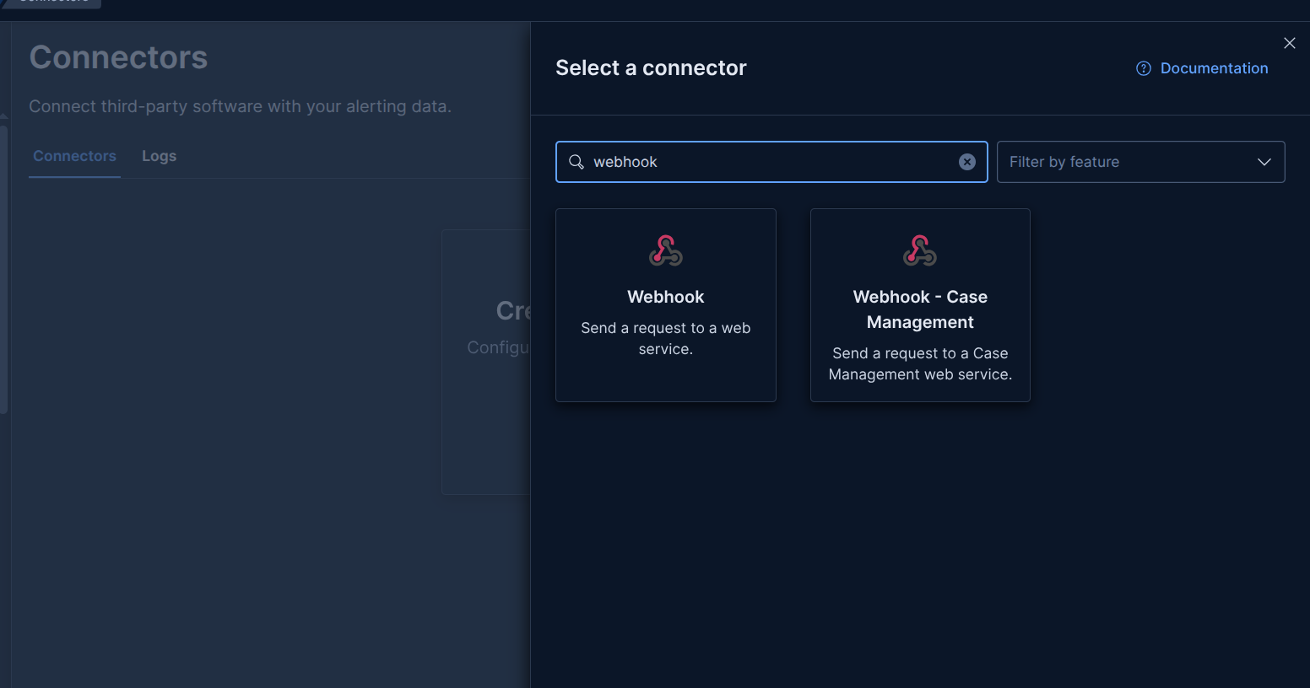
Figure 3: Webhook connector selection

Add Custom HTTP header with field X-API-Key=<Paste API key created from osTicket page in here>
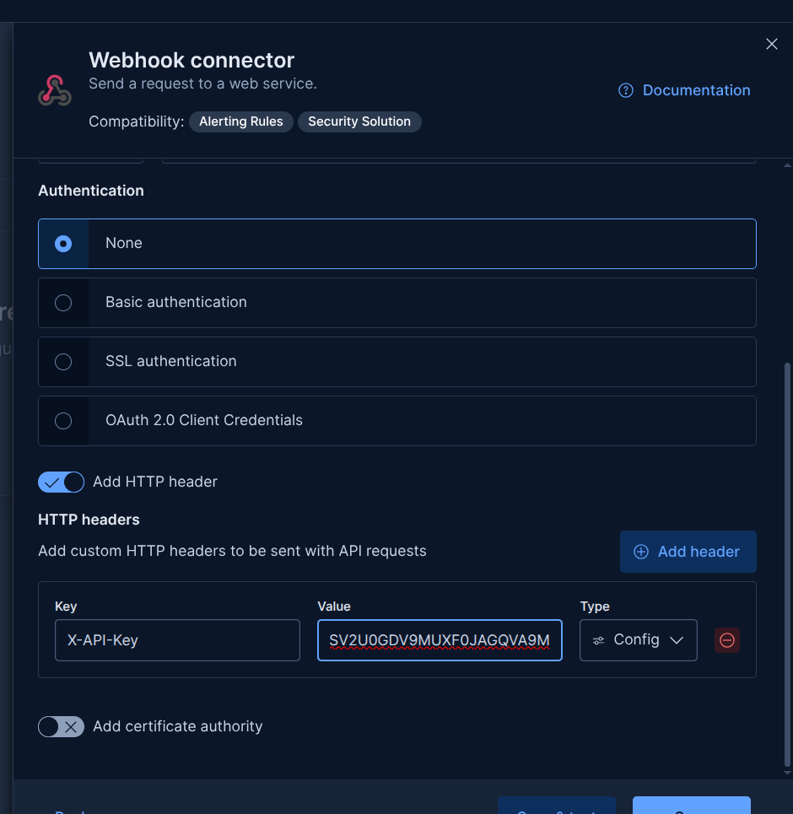
Figure 4: Webhook connector configuration

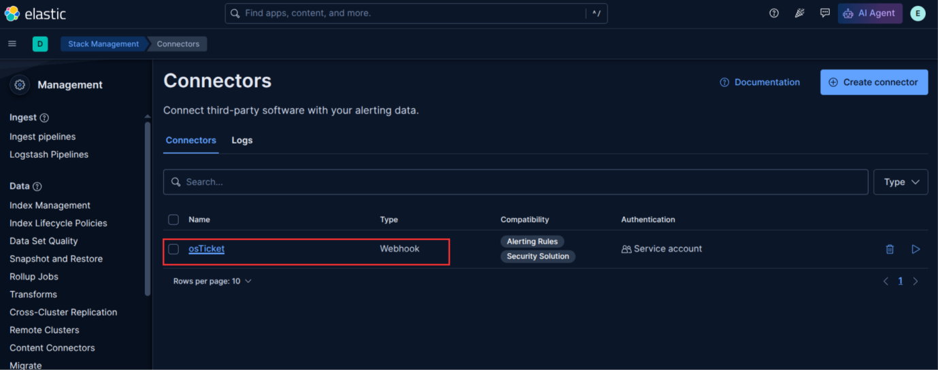
Figure 6: Configured osTicket Connector
We can see in Figure 6, the connector is available for Alerting Rules and Security Solution, and it uses a service account for authentication.
- Verify step
If you are a beginner, you can access to this link to refer some example tickets: https://github.com/osTicket/osTicket/blob/develop/setup/doc/api/tickets.md

Method 1: using CLI
An osTicket API endpoint for creating new tickets is: http://172.31.0.5/osticket/upload/api/tickets.xml and I will test ticket creation via curl utility:

root@MyDFIR-ELK:~# curl -X POST "http://172.31.0.5/osticket/upload/api/tickets.xml" -H "X-API-Key: QF9BRSW89ZCZJTZ8YVHSKQCAIUSV2U0GDV9MUXF0JAGQVA9M" -H "Content-Type: application/xml" -d '<?xml version="1.0" encoding="UTF-8"?>
<ticket>
<name>Test User</name>
<email>phamv4356@gmail.com</email>
<subject>Test Ticket</subject>
<message>Test message body</message>
<topicId>1</topicId>
</ticket>'

Example Output (raw case id):
395943
Now, let’s move on to the osTicket page. Here, we can see an open ticket with the ticket number “395943”:
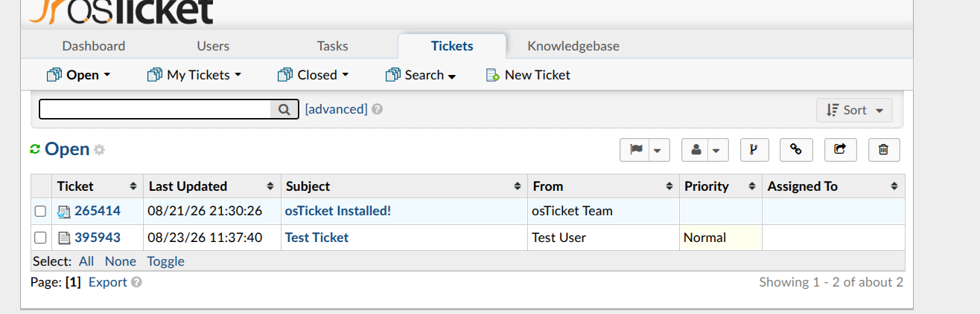
Figure 7: Open tickets list

Method 2: Using Test Connector feature directly from Kibana GUI
From the connector configuration page, you can paste the payload pattern above into the Body section under the Test tab and run it. The Case ID should then be displayed in the Results section.
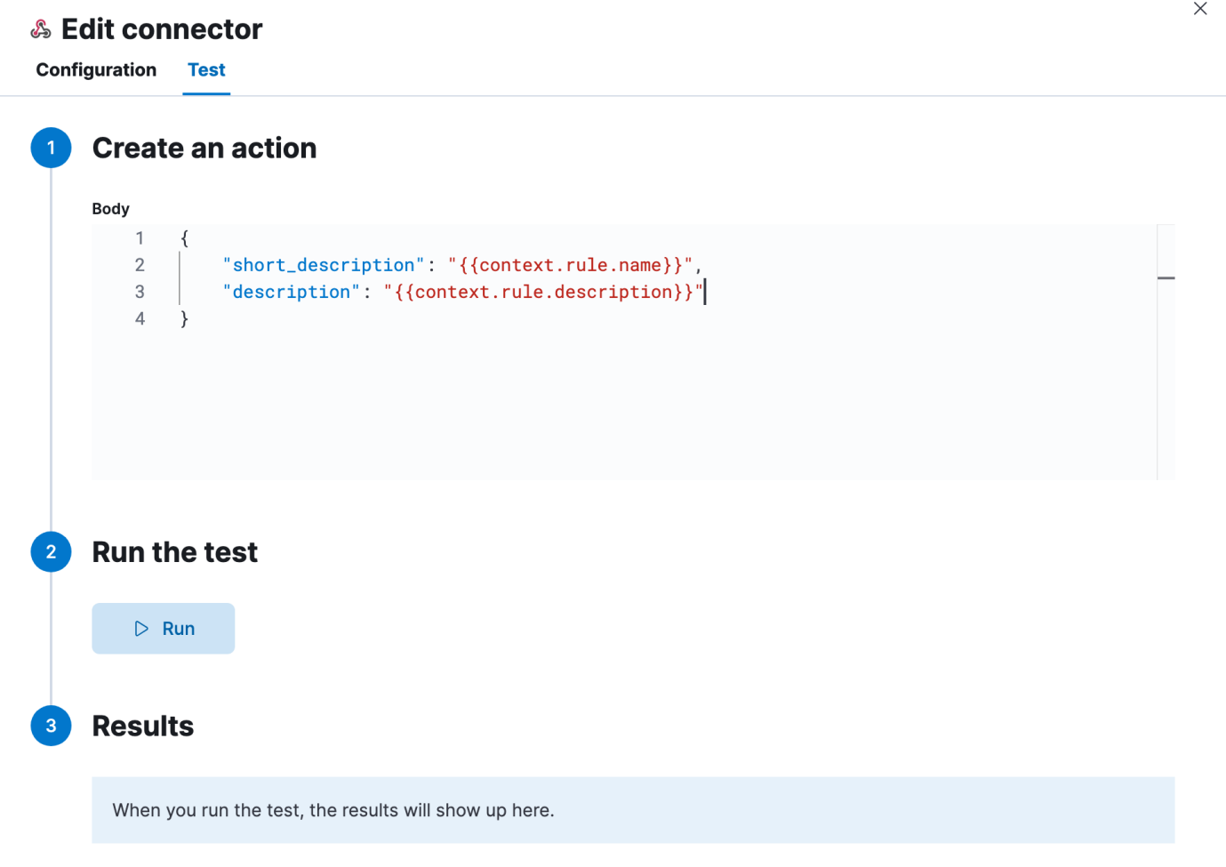
Figure 8: Testing ticket creation from Kibana GUI Illustration

